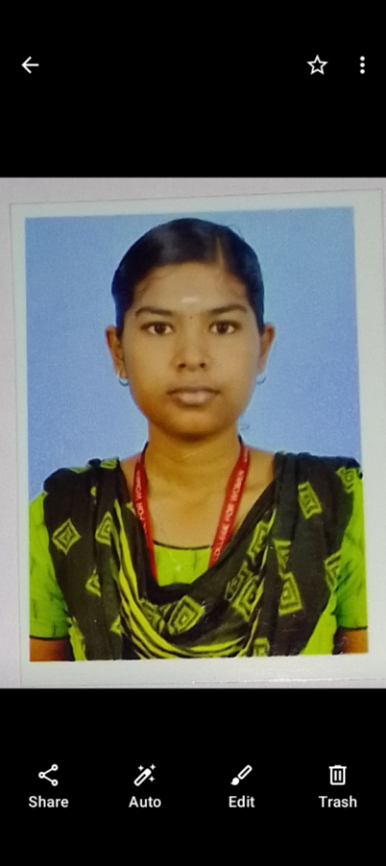**Name** :Nandhini V

**Address** :181,Nagarajapuram,

Thalavumalai,Arachalur,

Erode-638101.

**Email id:**nandhinivenkat2004@gmail.com

**Mobile no:**7010718075

9965080725

**CAREER OBJECTIVE**

TO working in a innovative and challenging environment extracting the best act of me, enhancing my professional skills with learning and experience for career growth

**ACADEMIC QUALIFICATION**

|  |  |  |  |  |
| --- | --- | --- | --- | --- |
| **Course** | **Institution** | **University/Board** | **Year of passing** | **Aggregate** |
| **BSC(Information Technology)** | **Navarasam arts and science college for women** | **Bharathiar University** | **2024** | **85.13 %** |
| **HSC** | **Government HR SEC School Arachalur** | **State board** | **2021** | **82.24%** |
| **SSLC** | **Government HR SEC School Arachalur** | **State board** | **2019** | **72.6%** |

**Skills:**

* Willing to learn and adapt to new opporties and challenges
* Easy to adopt with other
* HTML
* JAVA
* PYTHON
* Power BI

**Extra Curricular Activities**

* Play Throwball

**Co-Curricular Activities**

* Attend nation level seminar
* Paper presentation in IOT
* Attend workshop on Cloud Computing
* Completed spoken English in Shakespeare Institute

**PERSONAL DETAILS:**

**DOB:** 18.01.2004

**Parent’s Name**: Mr. Venkatachalam,

Mrs. Puspalatha

**Parent’s occupation**: Tailor,

Coolie

**Nationality** : Indian

**Languages Known** : Tamil(Speech,Write),English (Speech,Write)

**Hobbies** : Cooking, Gardening, badminton.

**DECLARATION**

I hereby declare that the above details are true to the best of my Knowledge. If I have been recruited, I will be sincere and dedicated to my job.

Place : Erode

Date : 16.9.2023 ( Nandhini V )